Producers, Consumers and Decomposers
The biotic community of any ecosystem can be divided simply into producers, consumers and decomposers.
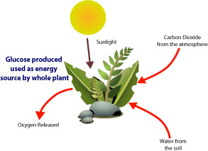Producers are organisms that make their own organic material from simple inorganic substances. For most of the biosphere the main producers are photosynthetic plants and algae that make glucose (sugar) from carbon dioxide and water.
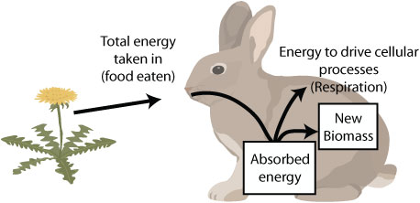Consumers are organisms that obtain energy by eating or digesting other organisms. There are three types of consumers, the herbivores (eat only producers), omnivores (eat producers and other consumers), and carnivores (eat only other consumers). By eating other organisms they gain energy from that organism.
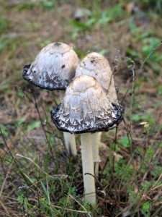Decomposers are the waste managers of any ecosystem. They are the final link in a food web, breaking down dead organic matter (DOM) from producers and consumers and ultimately returning energy to the environment. Examples are Mushrooms, bacteria, beetles, snails, slugs, and worms.
Name _________________________________ Bell ________ Date _____________

Producer, Consumer, Decomposer Worksheet
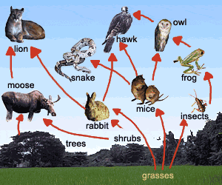
Directions: Using the food web, correctly fill in the energy pyramid by doing the following:
- Divide the pyramid into 4 sections and label each trophic level (producers, primary consumers, secondary consumers, tertiary consumers)
- Place each organism into the appropriate section of the pyramid. (Remember: animals CAN be in multiple levels).

1. Label the Energy Pyramid. Place each of the organisms from the food web into the appropriate section of the Pyramid. (An animal CAN be in multiple levels!)

2. Add two decomposers to the OUTSIDE of the energy pyramid. Some examples of decomposers are Mushrooms, bacteria, beetles, snails, slugs, and worms. Why do you think decomposers should be on the outside of the pyramid?

__________________________________________________________________ ______________________________________________________________________________________________________________________________________________________________________________________________________

3. If there are 150,000 kcal at the producer level, show how many kcal of energy are in each of the trophic levels. (on the pyramid) What is the rule to show how much energy moves on?

__________________________________________________________________

4. Why do you think the number of organisms decreases as you go up the food chain? (Example – why are there less lions in the world then there are rabbits?)

________________________________________________________________________________________________________________________________________________________________________________________________________________________________________________________________________

5. The list of organisms below are all consumers. Tell me if they are Herbivores, Carnivores, or Omnivores.

Caterpillar ________ Cow _________ Human __________

Horse __________ Pig __________ Owl _____________

Snake __________ Wolf_________ Goat ____________

Chicken __________ Fly __________ Rabbit ___________

Sheep ___________ Spider _______ Bear ____________

